Social Studies 6 Name __________________________
Ancient China

The Great Wall of China

Early History of the Great Wall
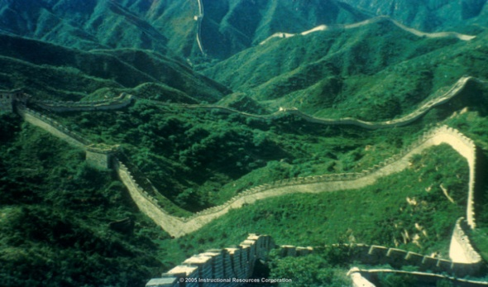
The Great Wall of China is not a single structure but a series of walls, watchtowers, and natural barriers. It was built over a period of 2,000 years and stretches more than 5,000 miles.
As early as 500 BCE, Chinese states had begun building walls to protect themselves from nomadic invaders. During the Qin Dynasty, the emperor, Qin Shi Huang Di, was determined to connect all the sections and create one Great Wall to protect the country. To secure his northern border against pastoral people of the steppe, Qin Shi Huang Di put a huge force of laborers to work connecting the separate walls into a single system that was over 1,500 miles long. Qin Shi Huang Di envisioned a great wall that would prevent invading tribes from entering China and discourage his subjects from leaving the empire.

Building the Great Wall

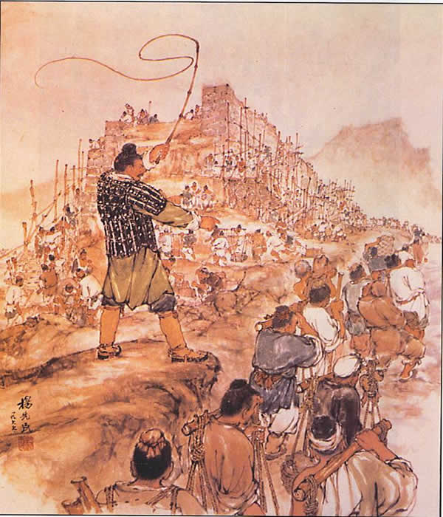
Meng Tian, the emperor’s most trusted general, supervised at least 300,000 workers. Soldiers, peasants, disgraced government officials, and convicted criminals worked to build the Great Wall of China. The workers labored under extremely harsh conditions. First, the regions in which the builders worked were often dangerous and difficult to reach. The wall was constructed through twists and turns of high mountain peaks, partial deserts, swamplands, and beds of quicksand. Second, the weather across northern China ranged from bitterly cold in the winter to blazingly hot in the summer. Exhausted workers often collapsed as a result of the weather extremes, and a great many became ill and died. Finally, builders often had to interrupt their work to fight off invaders. Scholars do not know how many workers died while building the Great Wall, but some believe the total to be in the tens of thousands. Chinese historians often refer to the Great Wall as “the longest graveyard in the world” because of the countless number of workers buried within the wall itself.

The Completion of the Great Wall
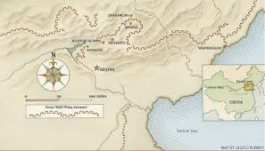
It took Meng Tian and his workers more than ten years to complete the first phase of the Great Wall. When it was finished, it extended more than 1,500 miles along China’s northern border. The eastern half of the wall was made of stone and brick, while the western half consisted of a massive wall of dirt. The average height of the Great wall was about 25 feet, and its base was anywhere from 15 to 30 feet thick. Despite its immense size, the Great Wall did not, in fact, successfully prevent invaders from entering China. For example, the Huns successfully invaded China during the third century BCE and ruled the northern part of the country for more than 200 years.

The Legacy of the Great Wall

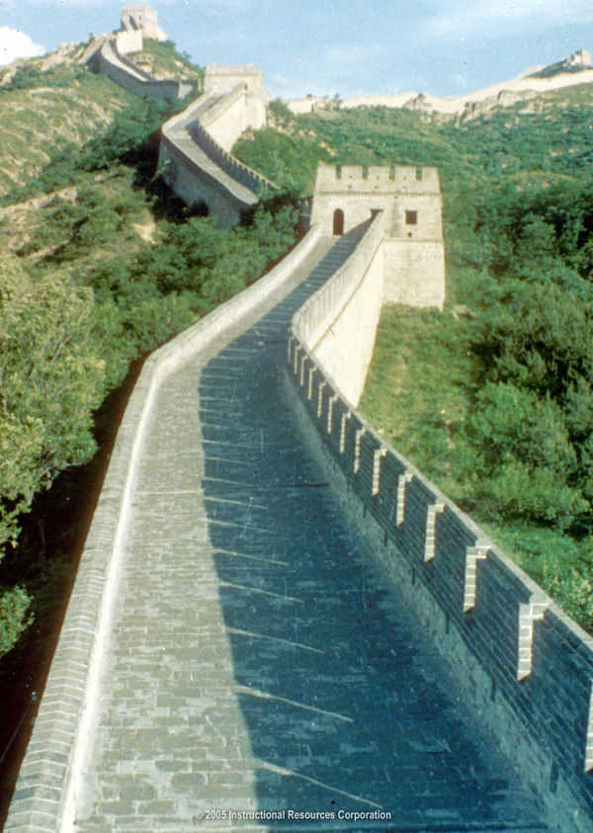
From the Qin to the Ming Dynasty, many of China’s rulers worked to repair, improve, and extend the Great Wall. After the Ming Dynasty, the Wall fell into disrepair for a long period of time. Many parts eroded and were lost. At that time, there were many people in China who viewed the Great Wall as a symbol of oppression and great waste. In the 1960s, followers of the leader, Mao Zedong, intentionally destroyed sections of the Wall. When foreigners visited the country, they saw the Wall as a symbol of great strength and endurance. Over time, the people of China began to embrace their Wall. It is now, for many, a source of pride.

1. The Great Wall of China was built over a period of ___________ years and stretches more than _____________ miles.

2. The ____________ Dynasty began building the Great Wall of China.

3. What were two reasons Qin Shi Huang Di decided to build the Great Wall of China?

______________________________________ ________________________________________________

4. The four groups of people that worked to build the Great Wall of China were

___________________ ____________________ ___________________ ________________________

5. List and explain three examples of the harsh conditions faced by those who built the Great Wall of China.

______________________________________________________________________________________________

______________________________________________________________________________________________.

6. Why is the Great Wall often referred to as the “longest graveyard in the world?”

_____________________________________________________________________________________________.

7. The phrase “the longest graveyard in the world” is an example of a(n): a. simile b. metaphor c. analogy

8. The eastern half of the wall was made of _______________ and __________________, while the western half was
made of_______________________.

9. The ________________________ successfully invaded China during the third century.
Word from reading | Synonym
10. | on purpose
11. | massive
12. | shamed
13. | rural
14. | grassland
15. | domination
16. | wandering
17. | stop
A section of the Great Wall is 5,500 miles long, and it has 723 beacon towers, 7,062 lookout towers, and 3,357 wall platforms.

18. If there was one person posted to guard every
beacon tower, lookout tower, and wall platform, how
many people would be needed in all?

Find two examples of the Five Themes of Geography from the reading.
19.

20.

Find two examples of Culture Patterns from the reading.
21.

22.

